PARTICULATE NATURE OF MATTER

BEHAVIOUR OBJECTIVES
At the end of this lesson, students should be able to:
- briefly explain each of the atomic models
- outline at least
- 5 postulates of Dalton’s Atomic theory, modification and discuss the reasons for modifications.
- draw the structure of the atom.
- express the 3 major sub-atomic particles and their characteristics (mass, charge).

Matter is anything that has mass and occupy space. It is basically anything that you can see, touch, weigh or smell. e.g. earth, shoe, car, moon, man. On the other hand, an atom can be defined as the smallest particle of an element that can take part in a chemical reaction. Some scientists have worked on atom, its compositions and have postulated different models and theories on atom. So, we will be discussing some of their works:

ATOMIC MODELS

- JJ THOMPSON MODEL
In 1897, J.J. Thomson performed a cathode ray tube experiment. Results from the experiment showed that all atoms contain tiny negatively charged subatomic particles called Electrons. He then proposed the Plum Pudding Model. The discovery of electron is accorded to his name.

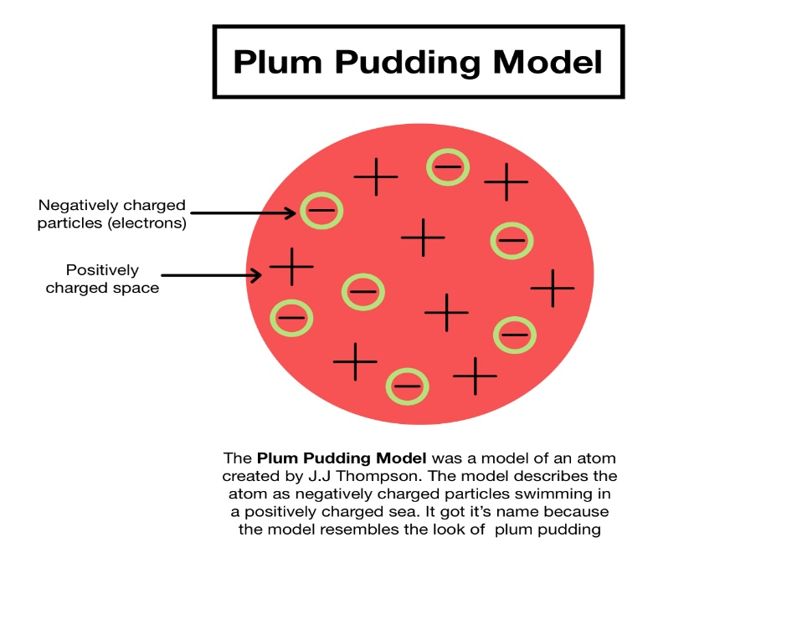

- RUTHERFORD ATOMIC MODEL
Rutherford performed gold foil experiment, where he used positively charged particles called alpha particles to bombard a thin-gold foil. He observed that most of the particles passed through the foil, while few of them deflected back. So, he concluded by proposing a theory called Nucleus theory of an atom. According to his theory, the atom consists of a small nucleus which contains the proton and neutron, while the negatively charged electron revolves around the nucleus.
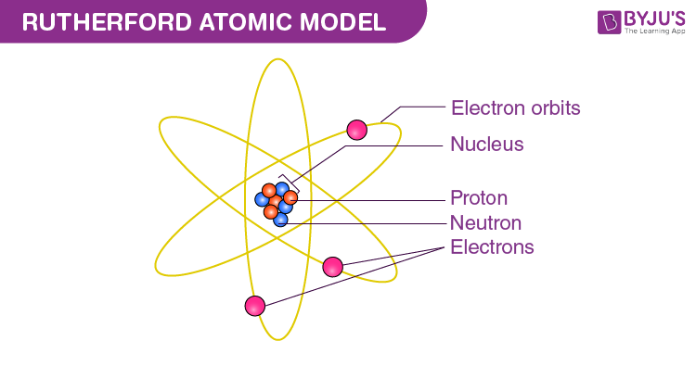

- BOHR ATOMIC MODEL
In the year 1913, Niels Bohr proposed an atomic structure model, describing an atom as a small, positively charged nucleus surrounded by electrons that travel in circular orbits around the positively charged nucleus like planets around the sun in our solar system, with attraction provided by electrostatic forces.
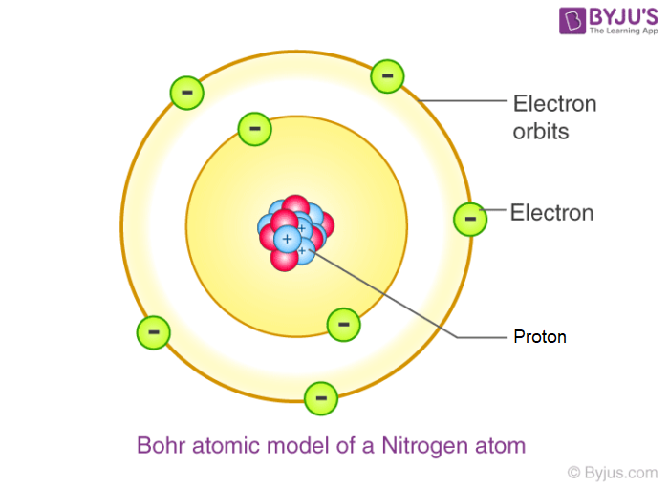

DISCOVERY | NAME OF SCIENTISTS
Electron  Proton  Neutron | J.J. Thomson  Rutherford  James Chadwick

DALTON’S ATOMIC THEORY
The idea that elements are made up of atoms is called the ATOMIC THEORY. John Dalton, British Physicist and Chemist proposed the atomic theory thus;
- All elements are made of small indivisible particles called atoms.
- Atoms can neither be created nor destroyed in any chemical reaction.
- Atoms of the same elements are alike in all aspect and are different from atoms of all other elements.
- Atoms of different elements can combine in simple whole number ratios to form compounds.
- All chemical changes result from the combination or the separation of atoms.

This theory was based on experimentation and chemical laws known at that time, and can still be taken as been valid. However, due to modern discovery, some modifications have been made on the theory.

Modifications of Dalton’s Atomic Theory

- All elements are made of small invisible particles called atoms.
Atom can no longer be regarded as indivisible because according to Rutherford’s discovery, atom is made up of three main subatomic particles called protons, neutrons and electrons.

- Atoms can neither be created nor destroyed.
This statement holds true for ordinary chemical reactions. But during nuclear reaction, like the nuclear fission of uranium -235; the nucleus is broken into simpler atoms, and during this process heat is released.

- Atoms of the same elements are alike in every aspect, and are different from atoms of all other elements.
The discovery of isotopes makes this statement unacceptable. Chlorine, for example, has two isotopes, ${}_{\text{17}}^{\text{35}}{\text{Cl }}$and ${}_{\text{17}}^{\text{37}}{\text{Cl}}$. The two isotopes have equal number of protons and electrons but different number of neutrons, i.e. different mass number.

- Atoms of different elements can combine in simple whole number ratio to form compounds.
This statement is only true for inorganic compounds which contains few atoms per molecules. However, carbon forms very large organic molecules, such as proteins, fats and starch.

Modern Atomic Theory (Modified Dalton’s Atomic Theory)

- All matter is composed of small particles, some of which are electrically neutral, some are positively charged while others are negatively charged.
- Atoms of the same elements are not alike, but may have different masses. Atoms of the same element with different masses are called ISOTOPES.
- Atoms of different element can combine to form molecules.
- Molecules are the smallest particles of a compound that have the properties of the compound.
- Molecules may be broken down and when this happens, they no longer have the properties of a compound.

Structure of Atom/Sub-Atomic Particles
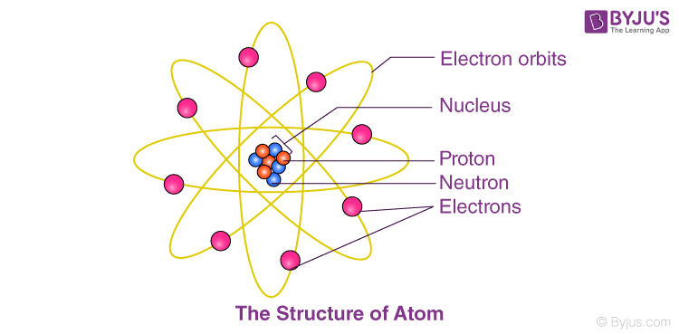

According to Rutherford theory, the neutrons and protons make up the nucleus of the atom, the nucleus is then surrounded by electrons in an orbital manner. Atoms are electrically neutral because they contain equal number of protons and electrons.

Particles | Mass | Charge
Proton  Neutron  Electron | 1 unit  1 unit  1/1840 unit | Positive (+)  Neutral  Negative (-)

DRILL QUESTIONS

- State 3 postulate of Dalton atomic theory
- List 2 limitations of this theory
- What is the structure of an atom according to Rutherford?
- List the sub-atomic particle an atom and their charges

